.

(1)Write a program to check 3 conditions by using ifelse ladder
(A)
public class Ifelselad
{
public static void main(String args[])
{
int a=4,b=5,c=1;
if(a==b && b==c)
System.out.println("the three numbers are same");
else if(a==b && b>c)
System.out.println("the a and b are largest numbers");
else if(a==c && c>b)
System.out.println("the a and c are largest numbers");
else if(b==c && c>a)
System.out.println("the b and c are largest numbers");
else if(a>b && a>c)
System.out.println("the a is largest numbers");
else if(b>a && b>c)
System.out.println("the b is largest numbers");
else if(c>a && c>b)
System.out.println("the c is largest numbers");
}
}

OUTPUT:
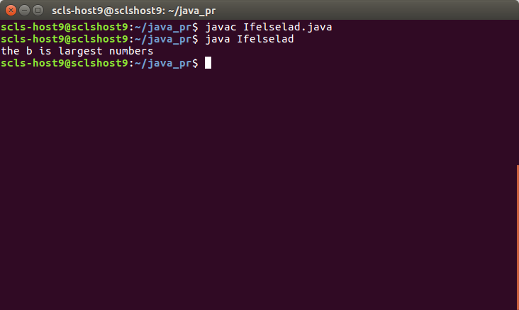

(2) Print 2 table by using (a) for loop
(b) while loop

(A)
public class Table2for
{
public static void main(String args[])
{
for(int i=0;i<11;i++)
{
System.out.println("2 x "+(i)+" = "+(i*2));
}

}
}

OUTPUT:

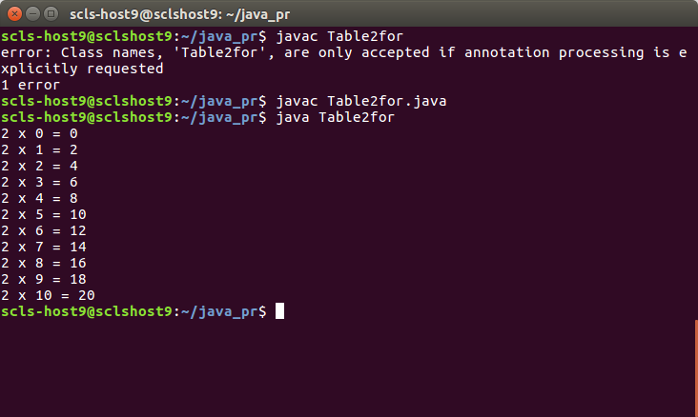

public class Table2while
{
public static void main(String args[])
{
int i = 1;
while(i<11) {
System.out.println("2 x "+i+" = "+i*2);
i++;
}
}
}

OUTPUT:
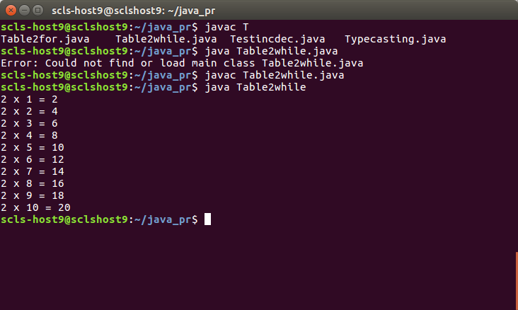

(3)Write a program to test pre-increment, post-increment, pre-decrement, post-decrement
(A)

public class Testincdec
{
public static void main(String args[])
{
int a= 7;
System.out.println(a++ + a++);
System.out.println(a++ + --a);
System.out.println(--a - --a);
System.out.println(a++ - ++a);
System.out.println(++a - ++a);
System.out.println(a++ - ++a);
}
}

OUTPUT:
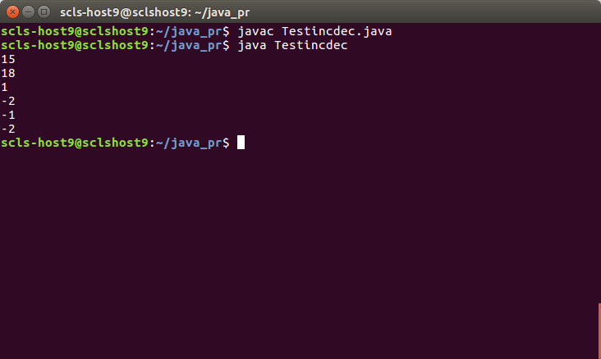

(4)Write a java program to print grade A if marks greater than 80 and to print grade B if marks is in between 60 and 80. And also to print grade c if marks are below 60.
(A)

public class Grade
{
public static void main(String args[])
{
int marks=82 ;
if(marks > 80)
System.out.println("grade is A");
else if(marks > 60 && marks < 80)
System.out.println("Grade is B");
else if(marks < 60)
System.out.println("Grade is c");
}
}

OUTPUT:
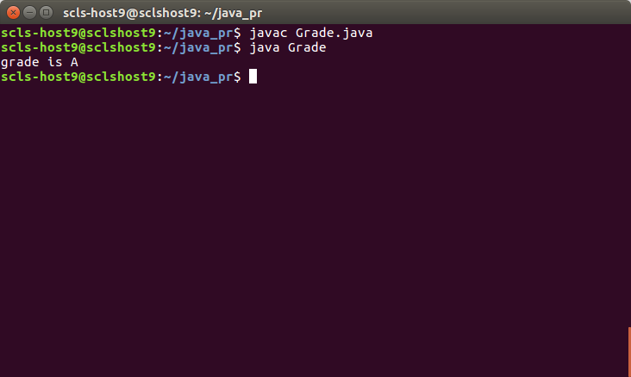

(5)Write a java program to demonstrate implicit and explicit typecasting
(A)

public class Typecasting
{
public static void main(String args[])
{
//implicit
int a = 7;
long k = a;
System.out.println(k);
// explicit
short b = 8;
byte k1 = (byte)b;
System.out.println(k1);
}
}

OUTPUT:

